Slant Rhyme Couplets

🎯 What is Slant Rhyme Couplets
# Source: Chatgpt (GPT-4-turbo) at [8/2/2025]
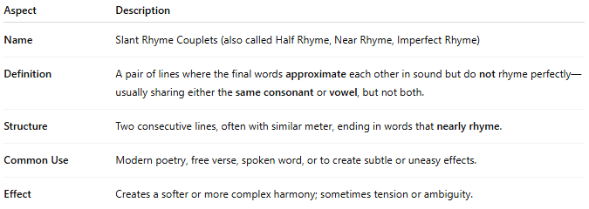
Aspect | Description
Name | Slant Rhyme Couplets (also called Half Rhyme, Near Rhyme, Imperfect Rhyme)
Definition | A pair of lines where the final words approximate each other in sound but do not rhyme perfectly—usually sharing either the same consonant or vowel, but not both.
Structure | Two consecutive lines, often with similar meter, ending in words that nearly rhyme.
Common Use | Modern poetry, free verse, spoken word, or to create subtle or uneasy effects.
Effect | Creates a softer or more complex harmony; sometimes tension or ambiguity.

✅ Example of Slant Rhyme in a Couplet
# Source: Chatgpt (GPT-4-turbo) at [8/2/2025]
She watched the fire begin to fade
Alone she stood beneath the shade
- "fade" and "shade" share the -ade ending: some might argue it's close to perfect, but pronunciation differences (especially stress or tone) can make it function as a slant in certain accents or poetic meters.
Another clearer slant rhyme example:
The blade was sharp and cut the skin
He felt the pain begin within
- "skin" / "within": share consonant n, but different vowel sounds → slant rhyme.

